**Lab assignment 08: shell**

For this exercise, you will be writing an application that simulates the shell game. The user is presented with three shells (you can add images, if you like) and must choose which shell is hiding the randomly positioned pea.

Required project name

shell

Required Directories

shell  
|- html  
|- css  
|- js

Required Files

README [Read up on the README](http://profmjs.blogspot.com/2015/09/readme-file.html)  
game.html  
lab08.css  
shell.js

Output Requirements

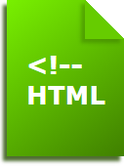Your game.html page will need to display three shell images or a description for the user. You will also need three radio buttons and three input buttons. The radio buttons correspond to the shells; the input buttons are for restarting the game, making a guess, and resetting the user's game stats.  
  
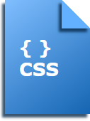Create a CSS file named lab08.css that is used by game.html page to style the content. You do not need much in the stylesheet for this lab. Just specify a background color and font for the display text.  
  
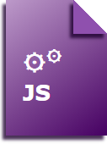Create a JavaScript file named shell.js that controls the enabling and disabling of buttons as needed, checks for the user's guess matching the randomly placed pea, tracks the number of games played and won, and resets the stat counters.  
  
Remember to place the README file in the adv-rpg directory.

Due Date

Monday, November 9th, 8am